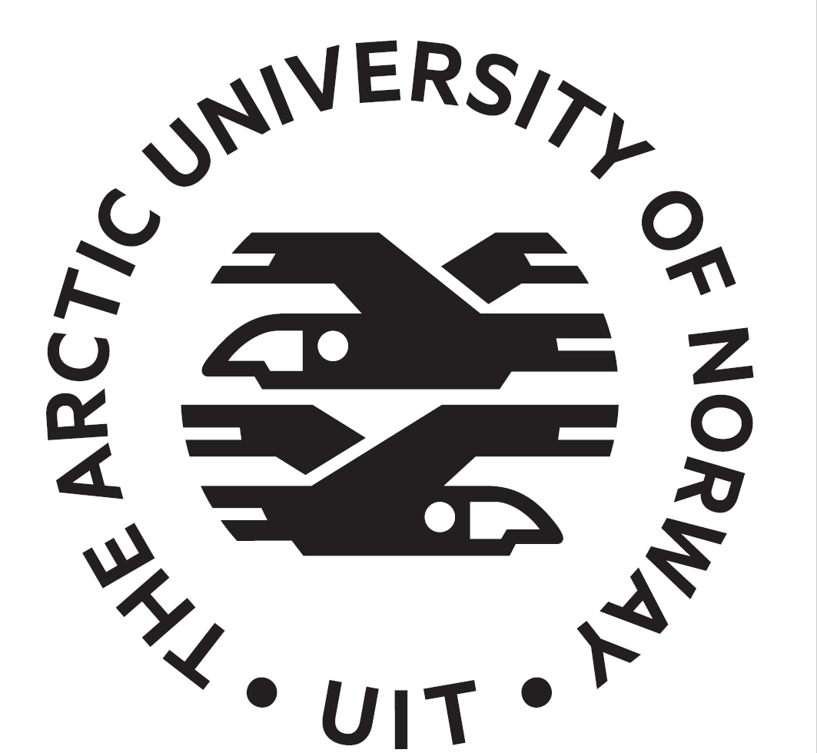
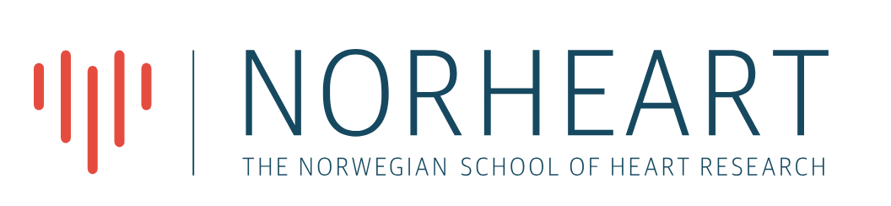

11-12th of May 2026 – UiT the Arctic University of Norway

NORHEART Seminar: "Mechanisms in Cardiac Metabolism and Mitochondrial function: Highlighting Translational Aspects»
We are excited to announce a lunch-to-lunch seminar hosted by UiT on May 11-12th 2026 titled "Mechanisms in Cardiac Metabolism and Mitochondrial function: Highlighting Translational Aspects». This seminar aims to foster collaboration and exchange knowledge on ongoing and planned research projects in the fields of metabolism and cardiac research.
The event will feature presentations from local researchers, invited speakers, and other participants. Additionally, there will be time in the program dedicated to discussing translational potential in cardiac research, models and techniques.
Please follow the link to the NORHEART website and register through the “Nettskjema” and indicate whether you will attend the lunch and dinner and whether you have allergies/food preferences we should consider.
The updated program is available below. There are still open time slots in the program for student talks or other attendees, and it is possible to register for a short talk (send mail to anne.hafstad@uit.no).
11th of May 2026 Sessions held in Aud 1 MH1-building UiT
SESSION 1 – Highlighting translational research on cardiac metabolism
Time | Title | Speaker
11:30-13:00 | LUNCH in “Lysgården” MH-building
13:00-14:00 | “Translational cardiovascular research - opportunities and challenges”. | Mathis Stokke (UiO)
14:00-14:30 | “Echocardiography in Limb-Girdle Muscular Dystrophy: Refinement of methods and handling of artefacts” | Assami Rösner (IKM, UiT/UNN)
14:30-14:45 | Coffee break
14:45-15:00 | «A porcine model for translational studies of Sepsis-Associated Acute Kidney Injury» | Kjellbjørn Jakobsen (IKM, UiT/UNN)
15:00-15:30 | “In vivo mice models of infective endocarditis” | Brage Håheim  (IMB, UiT)
15:30-16:00 | Panel discussion: How to increase translational potential in cardiac research
18-21 | Dinner at Suvi - Tromsø city center

12th of May 2026 Sessions held in Aud 1 MH1-building -UiT
SESSION 2 – Mitochondrial morphology and function in pre-clinical models of cardiovascular research

Time | Title | Speaker
09:00-09:45 | “Metabolic reprogramming in the diseased heart: the role of redox signalling and intermediary metabolism” | Anna Zoccarato  (Kings college London)
09:45-10:00 | “Mitochondrial remodeling in response to cardiotoxic stress” | Nelsy Efundem Tabako-Foncha (IMB, UiT)
10:00-10:15 | "Multi-modal light-sheet system for fast and gentle volumetric imaging". | Jon-Richard Sommernes  (NTFAK, UiT)
10:15-10:30 | “Assessing mitochondrial transfer in hiPSC-derived cardiomyocytes and engineered heart tissues” | Mauro Calvoli (IKM, UiT)
10:30-10:50 | Coffee break
10:50-11:10 | “Focus on engineered heart tissue transplantation: The HeartVision project” | Åsa B Birgisdottir  (IKM, UiT/UNN)
11:10-11:30 | “Lipid droplet dynamics in the cell” | Viola Nahse  (IMB, UiT)
11:30-11:50 | “Discovery of Novel Small Extracellular Vesicle MicroRNA Biomarkers in Pericardial Fluid: Potential for Enhancing the Diagnosis of Ischemic Heart Disease in Patients with Acute Myocardial Infarction” | Øystein Røsand (NTNU)
11:50-12:10 | “Liver-heart crosstalk in fructose-mediated metabolic dysfunction” | Joanna Konieczny  (IMB, UiT)
12:10-12:30 | Coffee break
12:30-13:15 | Panel discussion –Preclinical models in experimental cardiac research – caveats and possibilities.
13:15.... | Lunch followed by a tour of our labs at UiT for those who want to join!

